**Experiment:** **6** **Shahnaz Fathima N**

**230701302**

**Homepage Development using RAD Model and Axure RP**

**Objective:** Simulate the lifecycle stages for UI design using the RAD model and develop a small interactive interface using Axure RP.

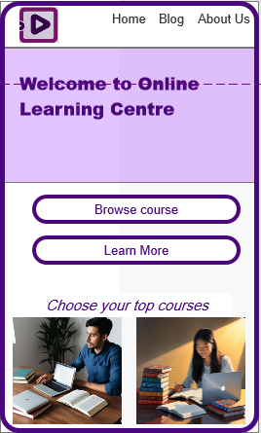

**Phase 1: Requirements Planning**

* **Key Features Identified:**
  + Navigation bar with options: Home, Blog, About Us
  + Welcome banner for the "Online Learning Centre"
  + Action buttons: *Browse course* and *Learn More*
  + Section to display top courses with images
* **Requirements Document:**
  + User should be able to navigate easily between pages.
  + Users can explore courses through action buttons.
  + Users should see a visual presentation of popular courses.

**Phase 2: User Design**

* **Tool Setup:**
  + Installed and launched Axure RP from [axure.com](https://www.axure.com/).
* **Project Creation:**
  + Created a new project named "Online Learning Centre Homepage."
* **Wireframe Design:**
  + Used Axure’s widget library to drag and drop:
    - A navigation bar with a logo and menu links.
    - A heading ("Welcome to Online Learning Centre") in a highlighted section.
    - Two call-to-action buttons for *Browse course* and *Learn More*.
    - A section titled *"Choose your top courses"* displaying two course images.
* **Interactions:**
  + Set interactions on *Browse course* and *Learn More* buttons to simulate page navigation.
* **Masters:**
  + Created a Master for the navigation bar to reuse across potential future pages.
* **Annotations:**
  + Added notes explaining the purpose of buttons, links, and image section.

**Phase 3: Construction**

* **Interactive Prototypes:**
  + Enabled click interactions on buttons.
  + Organized sections visually to mimic a real homepage layout.
* **Testing and Iterations:**
  + Previewed the homepage using Axure’s *Preview* mode.
  + Made adjustments to spacing, alignment, and font styles after visual inspection.

**Phase 4: Cutover**

* **Finalization:**
  + Finalized the homepage layout and button interactions.
* **Deployment:**
  + Exported the prototype for presentation/sharing.
* **User Training:**
  + Prepared a small demonstration on navigating through the homepage to explain usability.